Eco-Team Charter
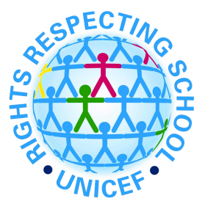
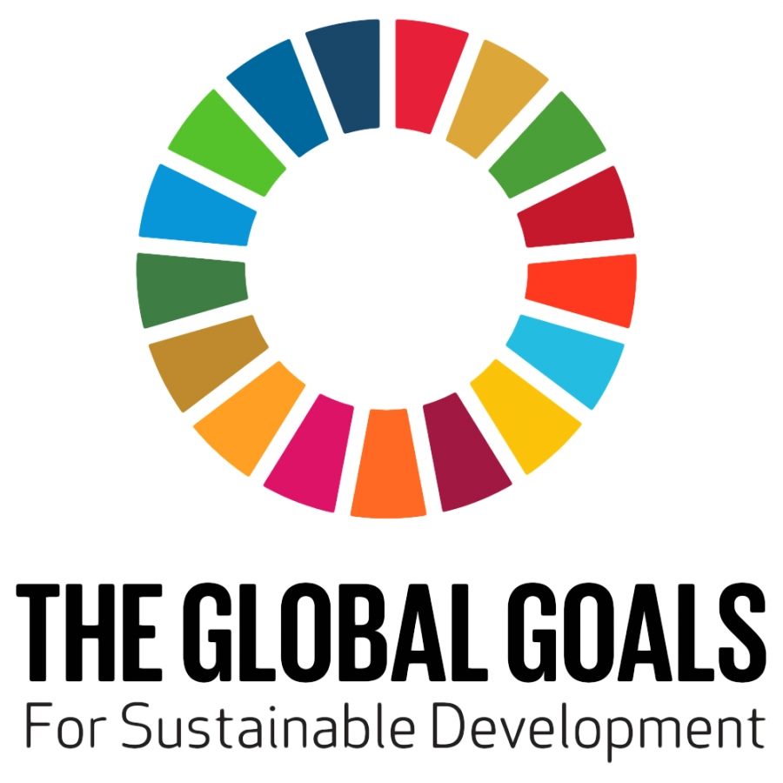

Created by the Eco-Team
Article 15
You have the right to choose your own friends and join or set up groups, as long as it sint harmful to anyone.
We joined the Eco-Team by our own choice.

Article 24
You have the right to the best health care possible, safe drinkging water, nutritious food, a clean and safe environment, and information to help you stay well.
We love to look after the school environment to help everyone stay well.

Article 29
Your education should help you to use and develop your talents and abilities. It should also help you learn to live peacefully, protect the environment and respect other people.
The Eco-Team enjoy looking after the school environment making it a peaceful place for everyone.
Global Goal 3 – Good health and well-being
Global Goal 5 – Gender Equality
Global Goal 11 – Sustainable cities and communities
Global Goal 13 – Climate Change
Global Goal 14 – Life below water
Global Goal 15 – Life on land

