Lunch Hall Charter
Created by the Lunch Monitors
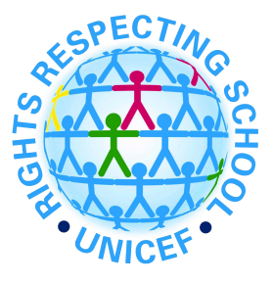
Article 15: You have the right to choose your own friends and join or set up groups, as long as it isn't harmful to others.
We will give children the choice of where to sit in the lunch hall.

Article 24: You have the right to the best health care possible, safe water to drink, nutritious food , a clean and safe environment, and information to help you stay well.
We will make sure that children have access to a balanced diet and drink lots of clean water.

Article 12: You have the right to give your opinion, and for adults to listen and take it seriously.
We will listen to everyone’s feedback and opinions about school lunches and the lunch hall environment.

Article 27: You have the right to food, clothing, a safe place to live and to have your basic needs met. You should not be disadvantaged so that you can't do many of the things other kids can do.
We will provide healthy food and water so that children have the energy to do well in their learning.

Article 13: You have the right to find out things and share what you think with others, by talking, drawing, writing or in any other way unless it harms or offends other people.
We will respect everyone in the lunch including the dinner ladies, lunch room staff, lunch monitors and other children.

Article 30: You have the right to practice your own culture, language and religion - or any you choose. Minority and indigenous groups need special protection of this right.
We will offer food that respects different cultures.

