Playground Charter
Created by the Playground Leaders
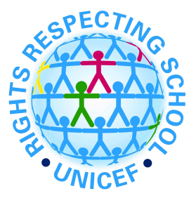

Article 31
You have the right to play and rest
We can play games and have areas to sit if we are tired

Article 19
You have the right to be protected from being hurt in body or mind
We will all work together to keep everyone safe to be kind to each other

Article 28
You have the right to a good quality education
We can learn new games and the Reading ambassadors can support us with our reading

Article 24
You have the right to the best health care possible, safe water to drink, nutritious food, a
clean and safe environment, and information to help you stay well
We will keep the playground safe and clean and everyone can have access to fresh air and drinking water

Article 12
You have the right to give your opinion, and for adults to listen and take it seriously
We will make sure that everyone is listened to

Article 16
You have the Right to Privacy
We have the right to use the toilets privately

